Basin Conservation
BaCon makes everything better!

Environmental Health of San Marcos River Watershed

Ekaterina Troudonochina
Julian Montejano
Mark Hiler
Veronica Gentile
Team Manager
Webmaster, GIS Analyst
GIS Analyst
GIS Analyst

Environmental Health of San Marcos River Watershed
Abstract
The city of San Marcos takes pride in its environment and protecting it, while promoting the growth of the city. The desire is to provide a home not only to its citizens, but also to preserve the wildlife residents and water resources of the city. The San Marcos River is home to a number of endangered species, namely the Fountain Darter, Texas Wild Rice, and the Texas Blind Salamander. These species are native only to the San Marcos River, so their conservation by ensuring the water quality is our number one priority. Overall, we will focus on the upper San Marcos River Watershed because it includes parts of the Edwards Aquifer recharge zone and is the main water source for the river. Increased impervious cover from the city’s expansion will affect the water runoff from the increase the non-point source pollution in the rain water entering the river. Another side effect is lessening the amount of water percolating into the aquifer. We used the land use/land cover (LULC) data given to us by The Meadows Center for the present time and for the year 2035. We also downloaded and researched all the remaining mandatory data and used the HSPF model within BASINS to evaluate if the increased impervious cover for the future proposed LULC plan will have an effect on the species in question. Our accumulative work resulted in some initial sediment data to analyze and indicates the potential of there not being a significant change from the future impervious cover increase Our research into the species, different water quality factors, and the management practices, as well as our sediment data, will prove to be a great foundation for any future projects around this topic.

Table of Contents
Abstract 1
1. Introduction 4
1.1 Background 4
1.2 Problem statement 5
1.3 Scope 5
Figure 1. Scope Map 6
2. Literature Review 6
2.1 Fountain Darter and Turbidity 9
2.2 Texas Wild Rice and Temperature 11
2.3 Texas Blind Salamander 13
2.4 GIS in Rio Grande Basin Study 14
2.5 San Marcos River Management Practices 16
3. Data 18
3.1 Inputs 18
Figure 2. TCEQ Table 18
3.2 LULC 19
Figure 3. Present LULC 20
Figure 4. Preferred LULC 20
4. Procedure 20
Figure 5. Watershed Delineation 21
Figure 6. Flowchart 22
5. Results 23
6. Discussion 23
7. Conclusion 24
8. References 25
Appendix I. Maps and Tables 27
Appendix II. Metadata 32
NHD Flowline 32
Preferred LULC 34
Appendix III. Contributions of Each Team Member 38

Environmental Health of San Marcos River Watershed
1. Introduction
1.1 Background
The beautiful City of San Marcos is expanding rapidly. Texas State University, located within the city, is a major cause for the population growth. Texas State is the fifth largest university in Texas. Austin and San Antonio are also expanding, causing people to start settling between the cities around the San Marcos area. This in turn is leading to an increase in the construction of businesses, roads, and housing. In order to complete these expansions, trees must be cut down and the wild grassy areas are changed to materials such as concrete, metals, and asphalt. All of these substances are types of impervious cover, or land cover that increases the water runoff. This water runoff contains man-made pollutants like chemicals, pesticides, and litter. Increased impervious cover also prevents water from filtrating into the ground, which permits the filtering out of pollutants before it reaches the ground water. This type of pollution is known as non-point source pollution. Non-point source pollution can enter the San Marcos River from all over the city and greatly affect the health of local aquatic species. The other form of harm to an aquatic system connected to the increased runoff is the effect on the replenishment of water in the system and the loss of water in the aquifer.
Some key species significant to this area are the Texas Blind Salamander, the Texas Wild Rice, and the Fountain Darter (to learn more about these species, please refer to the Literature Review). These species are endangered and known to live only in the upper San Marcos River, which makes the river and the whole Upper San Marcos Watershed an environmentally sensitive area requiring careful management. The health of the river and its inhabitants depends on clear, clean water, and the maintaining of the same approximate temperature. The Edwards Aquifer recharge zone is also located in this area, and many people depend on its water, not to mention that without the aquifer supplying water to the river, there would be no San Marcos River. This recharge zone is crucial to the aquifer because decreased water infiltrating the ground will cause the aquifer to have a lower water level which will affect the flow and level of the San Marcos River.

1.2 Problem Statement
The City of San Marcos requires assistance in creating geospatial datasets for estimating the impact of future land use demands and the changes to land cover on the environmental health of the Upper San Marcos Watershed. We will use TCEQ water standards, the criteria from the specific endangered species, and the comprehensive land use and land cover (LULC) prediction of San Marcos’ growth as provided by the City of San Marcos’ Design Rodeo Conference. This data will be used in addition to the powerful hydrological software, known as BASINS, to demonstrate to the city how the different amounts of impervious cover will affect the water quality of the river and watershed. We will compare the output to the requirements for the species in question and will provide the conclusions along with interactive maps to demonstrate the outcomes through our presentation, poster, and website.

1.3 Scope
The geographic extent of this project is the Upper San Marcos River Watershed, which is the San Marcos River until its confluence with the Blanco River. The western side of the city and its developmental planning are also taken into account up through the year 2035. All of the above mentioned area is crucial to the health of the river and its inhabitants.
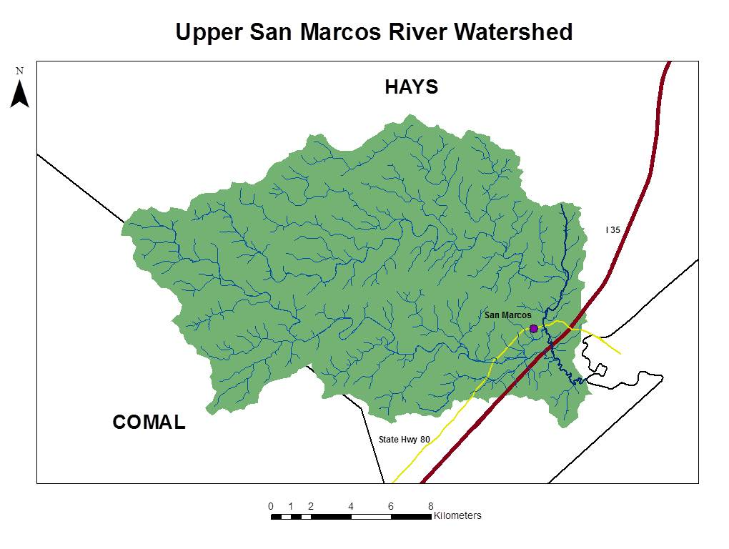
Figure 1. Scope Map

2. Literature Review
A premise of Team BaCon’s analysis for studying the effect of the impervious cover increase is through the direct focus on the health of specific species calling the San Marcos River home. These species, the Fountain Darter and Wild Rice, are connected to the standards provided by the TCEQ and EPA for water quality because in the present these standards are satisfying the requirements for their existence. Looking at government data in conjunction with the endangered species data provides a decent foundation for understanding the effects on the Upper San Marcos River Watershed.
The TCEQ standards are basic water quality standards and are a little more detailed then the standards needed for endangered species, and as a state institution its standards are obliged to match or surpass the federal government’s ones decided on by the EPA. The TCEQ has categorized the San Marcos River as a primary contact recreation area. This is an elaborate way for defining the location as one where people swim, fish, and float. It is also considered an Aquifer Protected area because of its use in providing for the domestic water supply. According to this entity’s research, the dissolved oxygen currently is at 6.0 mg/L. The maximum temperature that the river can reach before dire consequences is 78 °F and the TDS, or total dissolved solid, levels out at 400 Mg/L (Texas State University accessed 2012).
Currently, the normal conditions for the San Marcos River have remained historically consistent allowing the native species to survive in their natural habitats and producing a healthy ecosystem. The habitat is an aquatic environment and to regulate its health it is important to have general guidelines about its attributes. In general these attributes include temperature, the rate of the water flow, and the amount of oxygen dissolved in the water. The current situation for the San Marcos River is the following. Its temperature remains between 69.8 and 73.5º F year round. The flow rate, which can be discussed very in depth and based off of several different time frames, is able to be summed up in a simple way for our research purposes. The level where flow will cease is when the level of the water is below 52 cfs (cubic feet per second). This is affected by climatic activities of the region, storms or droughts, and mitigation actions. The dissolved oxygen level average recorded between 1992 and 2010 was 8.1 mg/L (TCEQ 2012)).
These statistics do not accurately depict the beauty of the river, but are important in how it demonstrates the current situation for our two endangered species, the Fountain Darter and Texas Wild Rice and by extension the Texas Blind Salamander. These standards permit Team BaCon to compare the needs of these species to the original characteristics of the river and understand what changes will lead to the harm of the San Marcos River’s clean and clear water status.
All this information comes with basis of certain assumptions. It is important to consider this reality and how unexpected alterations may affect the overall project at any point during its implementation. If a situation occurs before the conclusion of this research, drastically changing a specific criterion, then this data may need to be revisited to alter it appropriately. The assumptions presently used in the research for the San Marcos River are (TCEQ 2012).
1. Invasive species (or species that are not native in the area and after they are introduced they usually wreak havoc on the native inhabitants): The defined invasive species remain at current levels, both as to number of species and numbers of individuals/coverage.
2. The level of Gill parasites do not increase.
3. The amount of sediment does not increase in the river.
4. The level for Recreation remains at the current levels, meaning no new water-craft rental facilities or water parks.
5. The current dam configuration has not changed.
6. The flow recommendation information is not a reflection of the U.S Geological Survey as it pertains to discharge measurement accuracy and that no new buffers are added.
7. It is known that the Texas wild-rice survived the drought of record and without assistance was able to re-colonize the river.
8. Only current mitigation activities are practiced, no additional ones have been added.

Continuing on in our project with this understanding of the study area allows for better awareness and more attention to potential alterations which may be faced by us or those who continue our line of research. The information gathered about the San Marcos River in general assists in understanding the literature used for individual species and our own collected data.

2.1 Fountain Darter and Turbidity
An important output Team BaCon succeeded in retrieving was about sediment. Afterward, research was conducted to find information about the effect of sediment in relation to our focused endangered species. The report, “Effects of Turbidity and Visual vs. Chemical Cues on Anti- Predator Response in the Endangered Fountain Darter (Etheostoma fonticola)” was discovered. It is very recent, done between January and May of 2011. It is also local. The trials occurred in San Marcos at the San Marcos National Fish Hatchery and Technology Center. The recent dates and location of the research adds to the strength of the research in the eyes of Team BaCon. It is a specific study on one attribute of water quality - turbidity. We understand the increase of sediment to directly correlate with an increase in the turbidity of the water. Turbidity is the sediment floating in the water affecting its clarity. Anthropogenic stressors, including construction of impervious coverage, cause a significant impact on the water quality in relevance to turbidity.
The authors of this research paper did testing where they simulated the impact of turbidity on a specific aspect of the Fountain Darters’ biological and evolutionary traits. Combined, these traits are extremely connected to the behavior of the species and thus its ability to survive in its natural habitat. The trait focused on was the defense mechanisms used to respond against predatory threats, specifically freezing. The test examined the response to “four predator cue treatments (chemical, visual, chemical and visual, and no cues) [while] using a native predator, the green sunfish” (Swanbrow et al., 2012, p. 1). The responses were studied under both clear and impaired vision levels in order to understand the harm turbidity potentially poses to the survival of the Fountain Darter. The results of this study were very clear, with increased turbidity there was significant impairment to the anti-predator response which “may be of concern regarding the future management of this endangered species” (Swanbrow et al., 2012 p. 1). Fountain Darters have to contend with their natural predators in the wild along with the threats posed by human activities, including decreasing the water level from increased water usage which then compounds the increase in sediment by damaging the water level. The interconnectivity of these aspects in turn worsens the turbidity situation. After the conclusion of the research the report states, “Our data indicate[s] that a combination of visual and chemical stimuli is necessary to fountain darters for predator detection. Only the visual plus chemical treatment (treatment 3) differed from the control. The lack of anti-predator response (freezing) when only one signal (visual or chemical) was presented indicates that E. fonticola is unable to increase reliance on another modality when one signal is lost” (Swanbrow et al., 2012, p. 4). This data makes it feasible that the change in water quality is too rapid for the species to adjust to the change in order to maintain its ability to react appropriately to predators. This signifies the necessary intervention of human action for the protection of this endangered species.
In conclusion, they state these “…findings highlight the need for further study of the effects of turbidity on this endangered, endemic species as an indication of the impact on these darters and other similar endemics living in habitats currently threatened by fluctuating turbidity levels because of anthropogenic impacts” (Swanbrow et al., 2012, p. 5). This indicated the sediment amount in the water, and its effects on turbidity, severely affects the Fountain Darter if the levels are too high and can be hazardous to this sensitive species.
Our own research was priorly conducted on this native fish, which lives near the surface of the city’s river, before searching for the literature previously discussed. We did this in order to most efficiently utilize our literature reviews.. Information on its required environmental settings proved very useful while investigating related studies and our own research project. In general for this specific fish, the temperature must be maintained below 77 °F. The temperature needs are more specific when it comes to the reproduction of the species. Temperature is a key component to the larval production and their ability to survive. Any higher than 77°F and the larval production is reduced, even higher at 79 to 82°F causes a reduction in egg production, and then ultimately for death from over-heating (or thermal death) happens for the entire species at 91°F. The significant flow rate level for the Fountain Darter is 80 cfs daily average of total discharge. This amount of flow allows for fountain darter reproduction, but the species can tolerate a range between 50 and 100 cfs. The species dissolved oxygen needs are 4.0 mg/L minimum. Our data may focus on temperature and flow rate, but as previously mentioned, the inter-related characteristics of the river cause it to be pertinent and worthy of being knowledgeable on.

2.2 Texas Wild Rice and Temperature
The previous literature review over the Fountain Darter caused there to be a desire for more information pertinent to our second endangered species. Earlier research found that the Texas Wild Rice is a native aquatic vegetation and non-existent in any other location of the planet besides certain parts of the San Marcos River. Its sensitivity is mainly to the water quality and carbon dioxide concentrations. The flow rate is the main priority for the species. It will be negatively affected if the water falls below 100 to 80 cfs. Adding to the difficulty of protecting this indigenous water plant is its sensitivity to temperature and the report “EFFECTS OF WATER TEMPERATURE ON GROWTH OF THE FEDERALLY ENDANGERED TEXAS WILD RICE (ZIZANIA TEXANA)” explores this in amazing detail allowing Team BaCon to better comprehend the dependency of Texas Wild Rice on maintaining clean, clear water for the San Marcos River through protecting the Upper San Marcos Watershed. The research behind the temperature is significant because, “temperature is an important factor in metabolic processes, such as photosynthesis and respiration… understanding the effect of temperature on growth in Z. texana [Texas Wild Rice] will aid in determining the temperature tolerance ranges of the species both in the wild and in captive propagation” (Tolley-Jordan and Power, 2007, p. 3). Understanding the tolerance capability, the range of temperature for its best chance of survival, is an important component to consider in Team BaCon’s priorities requirements and this document provides the research for it.
In the ten week study done by the University of Alabama in 2007, the focus was on the influence of water temperature over the vegetative growth and reproductive capabilities for this water biota. The research indicated that the current temperature of the San Marcos River is the optimal one for the plant by revealing how “in cool water [the plants] accumulated less biomass and produced fewer and shorter leaves compared with plants grown in moderate and warm water…reduced temperatures most likely slowed metabolic activity, resulting in diminished plant growth in cool water” (Tolley-Jordan and Power, 2007, p. 8). The exact opposite seems true when the temperature leans in the other direction this plant when, “…grown in warm water allocated more biomass to reproductive parts at a cost to vegetative leaves compared with plants grown in moderate temperature water. Although it is characteristic of the species first to accumulate biomass in vegetative leaves then shift biomass to reproductive parts later in the growing season…that plants grown in warmer water developed more rapidly than plants grown in colder water, and their growth cycle was compressed” (Tolley-Jordan and Power, 2007, p. 8).
The sediment increase risks harming the flow-rate and temperature, compromising the successful growth of the Texas Wild Rice. It is important to use the data our team has uncovered and future data stemmed from the basis of our project to promote a strategy including the management of the San Marcos River’s temperature, “maintains the balance between vegetative and reproductive activity and the natural growth cycle of the species” (Tolley-Jordan and Power, 2007, p. 8).

2.3 Texas Blind Salamander
The Texas Blind Salamander is an endangered amphibian residing only in the underwater caves within the Edwards Aquifer. It is a translucent - white salamander with little pigmentation and no eyes. Both of these are adaptations evolved from living underground. It is usually about 3.5 to 5.5 inches long with long skinny legs and a finned tail. This salamander is a top predator in the ecosystem and it searches for prey by moving its head around to sense the surrounding environment for water pressure waves created by other animals. Its diet entails tiny snails, shrimp, and other aquatic invertebrates. Little is known about this species since they are in such an unreachable habitat. In order to survive they need a steady supply of fresh clean water into the Edwards Aquifer.
Population growth causes pollution and the impervious cover creates more runoff than infiltration. The combination of these problems poses a threat to the salamanders which could be hazardous to their survival. This is added to the already present threat from the over-pumping of water, if the runoff harms the water to trickling down too much then the lowered water level can and will kill off this sensitive species. The assistance required by the City of San Marcos for helping the Texas Blind Salamander prosper is to keep track of the land use and land cover of the city, conserve water, and prevent pollution. Our information for the Texas Blind Salamander was based on information acquired from Texas Parks and Wildlife Department and the National Wildlife Federation.

2.4 GIS in Rio Grande Basin Study
The “Use of spatial surrogates to assess the potential for non-point source pollution in larger watershed” is a similar study to our own. It has a focus on non-point source pollution in a watershed. Though our concentration is on the Upper San Marcos Watershed, the parts of the Rio Grande Basin residing in United States’ territory studied, provided a good precedent for research and explored useful tools for our situation. Our research is connected through the realization of a critical element required for the success and continuation of non-point source pollution prevention programs. It is important for any program to accurately utilize the limited time and funds available in the most effective manner in order to address priority areas, especially when studying large watersheds. By finding the data for future impervious cover situation of the City of San Marcos we will be contributing to this mutual goal.
Reading through this research, they also use a combination of hydrologic tools and GIS tools to understand the nature of the problem and to create a useful conclusion. In the Rio Grande Basin they used GIS to identify hydrological sensitive areas and locations facing excess storm water runoff to provide a rational restriction for pollutant-generating actions within the study area.
Their research, like ours, has a similar goal in terms of using GIS: “Geographic information systems [are] also a useful tool for water-quality-risk assessments. Risk assessments use landscape metrics, combined with the analytic capabilities of GIS software, to identify geographical areas exhibiting a high risk for generating water pollutants” (Moltz et al., 2011, p.2). Regrettably the document does not elaborate further on hydrological tools to use and has no relation to BASINS. The lack of BASINS in the studied project meant it did not encounter or discuss any of the difficulties faced by our team during our own research and is unable to assist us with suggestions for handling the situation.
On the other hand, this document does coincide with the new direction that Team BaCon’s project has taken during the research part of our project due to complications with the previously expected data acquisition. It provided examples for a possible future continuation of our project by its demonstration of identifying relevant information, non-point source pollution factors for consideration, and the organization of landscapes. They may not have been as focused on impervious cover as our project is, but their separation of their landscape into four categories for their source areas of the Rio Grande Basin were: developed - low intensity, developed - high intensity, pasture, and cropland. This concept for the division of land is easily connected to the concept of impervious cover and would be a potentially good way to go forth in the project with Team BaCon’s ability to apply more time and research for the impervious cover situation for the City of San Marcos. Lastly, the significance of this report is its emphasis on soil erosion on water quality and the necessity to accurately measure the situation.

2.5 San Marcos River Management Practices
There has been extensive information on the San Marcos River collected prior to this project and it will be useful to make note of it. The San Marcos River is a vital asset to the City of San Marcos and many groups have worked together for the “Report on Restoration Options for the San Marcos River”. This report is directly connected to the endangered species residing in the river and the requirements by the citizens of the surrounding area to promote the health of the aquatic system.
It states the needs for the protection of the river in several very clear objectives. All of these will be relevant to the Fountain Darter and Texas Wild Rice. There exist specific ones with complete pertinence to Team BaCon’s purpose. Importantly, this includes discovering the effects of impervious cover on the health of the river. Hopefully, the conclusions from our research combined with the knowledge found in this document will aid with either the promotion or discontinuation of these management practices depending on their success in protecting the San Marcos River. The final output analysis will be able to help define the important areas for several of the proposed approaches to protecting the river including numbers 30-32, 34 and 36 (EARIP Restoration Subcommittee, 2009, p. 11-12):
“30. Acquire land for retrofitting developed areas to follow better watershed protection;” which will take already developed areas and change them to have less pollution in the runoff.
“31. Acquire land for conservation purposes;” this is to protect undeveloped land and designate some land for regional wetland development.
“32. Create a zoning and management plan for the San Marcos River watershed;” proper zoning is able to designate a land use design that will benefit the San Marcos River.
“34. Create more stringent Structural and Non-structural BMPs;” BMPs, or Best Management Practices, are mandatory but rather limited, so actions must be taken to produce more rigorous practices.
“36. Rebuild streets near river for better water quality control: No coal tar derivatives in street materials within the San Marcos River watershed.”
As it pertains to these suggestions, this document states the research necessary to assist in these endeavors in Appendix I. The recommendations for handling the non-point source pollution situation’s aftermath, the sediment already in the river, and the unavoidable creation of the pollution in the present and future are logical and similar to our team’s own understanding of the situation. We understand that despite attempts to predict and comprehend the increase of impervious cover in the Upper San Marcos River region there is no feasible way to prevent all sediment in storm water run-off. The recommendations set by the collaborated authors of the paper in question include 5, 26, and 37 (EARIP Restoration Subcommittee, 2009, p. 8, 10, and 12):
“5. Remove floating debris from Texas wild-rice stands.” Any kind of debris trapped in the wild rice, like the unobstructed liter resulting from San Marcos’ expansion, will prevent photosynthesis and needs to be taken out of the river.
“26. Dredge fine sediment from specific areas of the river.” Urbanization causes an increased sediment load in the river, which makes it shallower and narrower. This extra sediment needs to be extracted carefully without disturbing the biota.
“37. Create low-cost loan programs for rain collection.”Making rain water collection more affordable to the residents of the city would reduce the demand on the aquifer.
Looking into this information is essential to preventing redundant work on the part of the City of San Marcos and utilizing the City’s resources by producing cohesive research available to both the public and private sector. Furthermore this data connects to other research involving “Management Guidelines for Endangered and Threatened Species of the Edwards Aquifer”. They both focus on pollution management including the prevention of erosion and runoff. This information has been useful in expanding our team’s data on the situation.

3. Data
3.1 Inputs
We have succeeded in acquiring all the input data for this project. We either received the data from the Meadows Center or through the BASINS database. Some of the data downloaded through BASINS included weather and climate data, a digital elevation model, and census/TIGER line data. Land use/land cover (LULC) data could have been downloaded as well, but we decided to use a more detailed version given to us by the Meadows Center. The 2035 predicted LULC data was also supplied by our partners, though the source was the city of San Marcos and the Design Rodeo. The design rodeo was a conference held in order to predict the most likely scenario for the population growth the city will experience. We also needed to download the National Hydrography Dataset plus (NHDplus), but the one that supposedly came with BASINS was discovered to be faulty and not compatible with the program. As an alternative, we obtained the NHDplus data from USGS. Unfortunately, we ran into difficulties while trying to incorporate this data into BASINS. We finally acquired working NHDplus data through assistance provided by the Meadows Center. Other data we needed was for the production of maps. This involved spatial data, such as county boundaries and stream layers. Those were obtained through the Texas General Land Office and Texas State University.
Since we needed to compare out findings to the survivability standards required for the species in question we learned of the flow regimes and temperature thresholds necessary to sustain their life. Guidelines for further water quality requirements were obtained through the Texas Commission on Environmental Quality. These guidelines include such parameters as dissolved oxygen, sulfide, and temperature levels. San Marcos TCEQ data can be seen below, Figure 2.
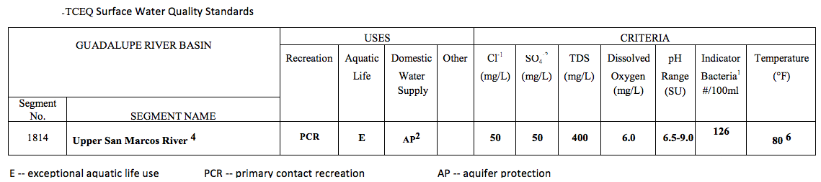
Figure 2. TCEQ Table

3.2 LULC
The land use and land cover data are at the core of our project. This data can be seen below. The first map shows the impervious cover percentages as they are today in the Upper San Marcos River Watershed. The City of San Marcos has the highest impervious cover out of the entire map area. The second map shows the predicted LULC for San Marcos in the year 2035, and it is clearly visible that the impervious cover around the city is predictably expected to increase dramatically.
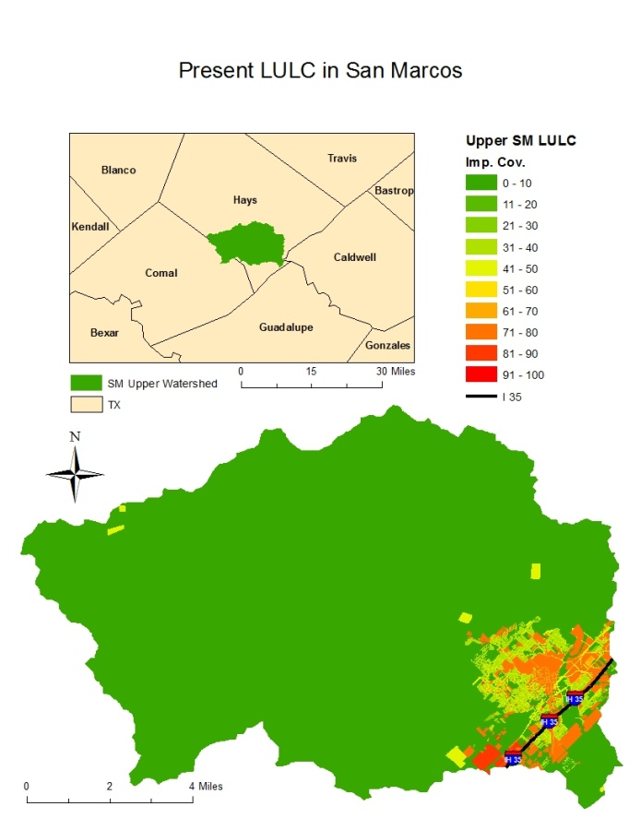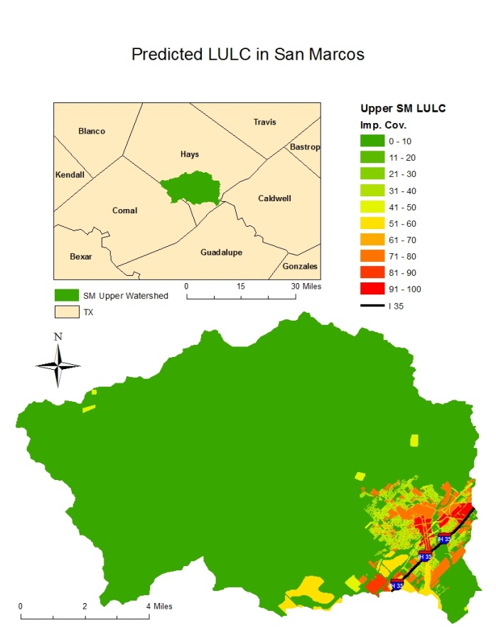
Figure 4. Preferred LULC
Figure 3. Present LULC

4. Procedure
In order to determine the effects impervious cover has on the Upper San Marcos River, we used a combination of BASINS’ HSPF model and research from our literature reviews. With these sources, we attempted to determine if the increased development/impervious cover will have an effect on the water quality and thus the various endangered species in the Upper San Marcos River.
During this project, we were using the program BASINS in conjunction with the HSPF model. BASINS is a multi-purpose environmental analysis system that integrates a geographical information system (GIS), national watershed data, environmental assessment, and modeling tools into one single program. HSPF stands for Hydrological Simulation Program—Fortran (US EPA, 2012). This model uses hydrologic processes such as rainfall and other meteorological records to compute stream flow hydrographs. We used HSPF to attempt an assessment of the effects of land-use change.
In BASINS we began by inputting various data, like the land use land cover data for the existing and preferred city plans. We downloaded some data from BASINS directly like the DEM and meteorological data for San Marcos (collected by the airport). The bulk of necessary data, land use land change and hydrologic data, were gathered from the Meadows Center. The next step was to determine the extent of the Upper San Marcos River watershed and split it up into various sub-basins. Within BASINS there is a watershed delineation tool, allowing the user to create watersheds by combining sub-basins.
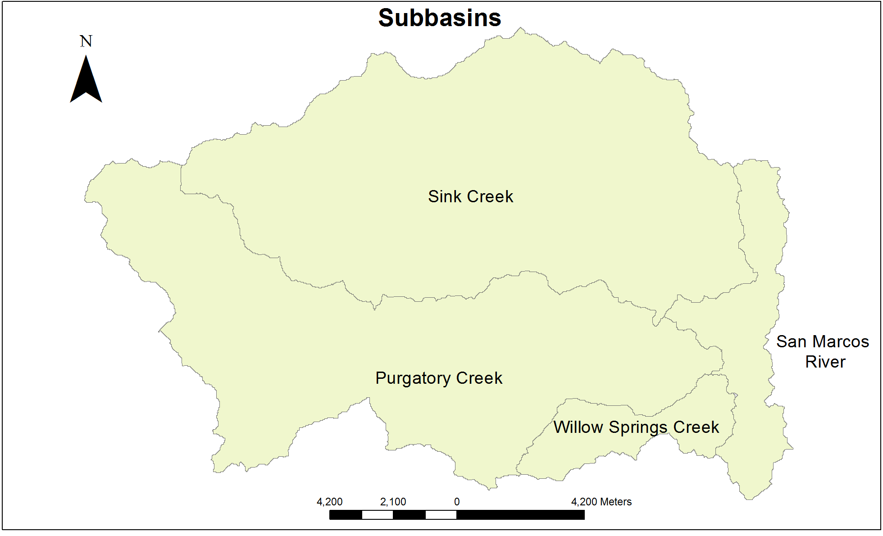
Figure 5. Watershed Delineation

After this, we set up the HSPF model. Here we ran into many problems and had to recreate entire project files a number of times before correctly diagnosing the various problems. Other than learning more about this program, which is new to all of the team members, these errors are what consumed most of our time. After HSPF was opened, the next step was to produce sediment storage data. This part went slightly smoother thanks to the help given by the GIS analysts at the Meadows Center, but errors continued to affect timeliness. Eventually, we were able to obtain rudimentary sediment data. Our next steps in this project would have been to set up HSPF again to obtain sediment transport data, bacteria, and temperature data, then nutrient and dissolved oxygen data. This data could be collected as a continuation of our project in the future since we were not able to get to it due to technical difficulties and requiring more time to conduct the project.
The data we gathered from the HSPF model was then compared and contrasted with results from similar constituents in the preferred land-use scenario to the existing one to determine if impervious cover does have an effect. We then took our data and combined it with what we learned through out literature research and came up with our conclusions on whether or not the future impervious cover will have an effect on the Upper San Marcos watershed and its endangered inhabitants. Please refer to the flowchart below.
Figure 6. Flowchart
5. Results
Due to technical difficulties and unforeseen barriers, the amount of data from BASINS and HSPF we were able to collect in the given time is smaller than originally expected. We were able, however, to derive Sediment Erosion data. This data includes storage of detached sediment, surface flow, storage of solids on impervious cover, and the total removal of soil and sediment.
Running the HSPF allowed us to produce tables showing the values of the sediment data for the preferred land use scenario as well as the existing land use. The results, after comparing the tables, have shown an insignificant amount of sediment erosion change in relation to harming the San Marcos River. At times in the data, there was a slight decrease in the amount of sediment removed and available to be removed because of the higher percentage of soil covered by an impervious layer.
More data is possible to be obtained, such as dissolved oxygen and temperature, but due to time constraints and lack of prior BASINS training, the data must be obtained at a future time in another research project.

6. Discussion
Our research is a great foundation for our results. Through it we discovered the extreme importance of temperature and turbidity to the Texas Wild Rice and the Fountain Dater, respectively. Sediment has effect on both of these water quality characteristics. Increased sediment can cause the river to be shallower and warmer than necessary. The San Marcos River is around 72°F year round, meaning the temperature cannot fluctuate too much or it will cause harm to its more sensitive inhabitants. A higher amount of sediment is also responsible for more turbulence which affects the visibility in the water. The visibility is crucial to the Fountain Darter’s survival because if the darter cannot see its predator it has no chance of escaping. Our preliminary sediment results appear to indicate there will not be a significant change in the amount of sediment in the water. The Texas Blind Salamander will only be affected if the water level in the Edwards Aquifer drops or if a significant amount of pollution enters the system. Both of these factors can be prevented if we maintain our current management practices Management Practices. Some important practices that focus specifically on water level and pollution are the standards set for water conservation and pollution by buildings. There are other important ones including preventing the disturbance of the river bottom, which houses the darters, or ripping up Texas Wild Rice. Overall, our research indicated the existence of many actions used to keep this river clean, healthy, and retaining its natural state.

7. Conclusion
In conclusion, our initial results seem to indicate that the predicted LULC change will not cause significant harm to the Upper San Marcos River Watershed and the species in question. Our findings, in combination with our research, show that the City of San Marcos should be safe developing in the selected areas for development in terms of sediment. The other factors pertinent to the river’s health still need further exploration. The predicted LULC plan seems to be safe as a hypothetical situation based on the research Team BaCon was able to acquire. We hope our information might prove to be useful to the City of San Marcos in its further developments.

8. References
City of San Marcos and Texas State University. 2012. Request for Proposal. San Marcos, TX.
Clary, C., Thomas Hardy, Melanie Howard, and Kristina Tolman. 2012. Meadows Center for Water and the Environment.
Edwards Aquifer Recovery Implementation Program Ecosystem Restoration Subcommittee, “Report on Restoration Options for the San Marcos River,” December 2009. http://www.eahcp.org/index.php/site/search?cx=013056156117723083075%3Amwotogbi8le&ie=UTF-8&q=Report+on+Restoration+options&sa=Search. Last accessed December 6, 2012.
Moltz, Heidi L. N., Walter Rast, Vicente L. Lopes, and Stephen J. Ventura. 2011. "Use of spatial surrogates to assess the potential for non-point source pollution in large watersheds." Lakes & Reservoirs: Research & Management 16, no. 1: 3-13. Academic Search Complete, EBSCOhost (accessed December 6, 2012).
National Wildlife Federation , "Texas Blind Salamander." Last modified 2012. Accessed December 8, 2012. http://www.nwf.org/Wildlife/Wildlife-Library/Amphibians-Reptiles-and-Fish/Texas-Blind-Salamander.aspx.
Swanbrow Becker, Lily J., Caitlin R. Gabor, and W. Koenig. 2012. "Effects of Turbidity and Visual vs. Chemical Cues on Anti-Predator Response in the Endangered Fountain Darter (Etheostoma fonticola)." Ethology 118, no. 10: 994-1000. Science & Technology Collection, EBSCOhost (accessed December 6, 2012).
Texas and Park Wildlife Department, "Texas Blind Salamander (Eurycea rathbuni)." Last modified 2012. Accessed December 8, 2012. http://www.tpwd.state.tx.us/huntwild/wild/species/blindsal/.
Texas Parks and Wildlife Department. 2012. “Management Guidelines for Endangered and Threatened Species of the Edwards Aquifer.” Edwards Aquifer Management Guidelines. http://www.tpwd.state.tx.us/publications/pwdpubs/media/pwd_bk_w7000_0013_edwards_aquifer_species_mgmt.pdf (accessed December 6, 2012).
Texas Commission on Environmental Quality (TCEQ). 2012. "Chapter 307 - Texas Surface Water Quality Standards: Rule Project No. 2007-002-307-OW." Accessed December 8, 2012.
Texas State University, "Challenges Facing the Edwards Aquifer RIP: Spring Run 1- 1956." Accessed December 8, 2012. gato-docs.its.txstate.edu/the-rivers-institute/.../Gulley LWP.pdf.
Tolley-Jordan, Lori R., and Paula Power. 2007. "Effects of Water Temperature on Growth of the Federally Endangered Texas Wild Rice (Zizania texana)." The Southwestern Naturalist no. 2: 201. JSTOR Life Sciences, EBSCOhost (accessed December 6, 2012).
US Environmental Protection Agency, "BASINS (Better Assessment Science Integrating point & Non-point Sources)." Last modified 2012. Accessed December 6, 2012.

Appendix I. Maps and Tables
Figure 1. Scope Map
Figure 2. TCEQ Table

Figure 3. Present LULC
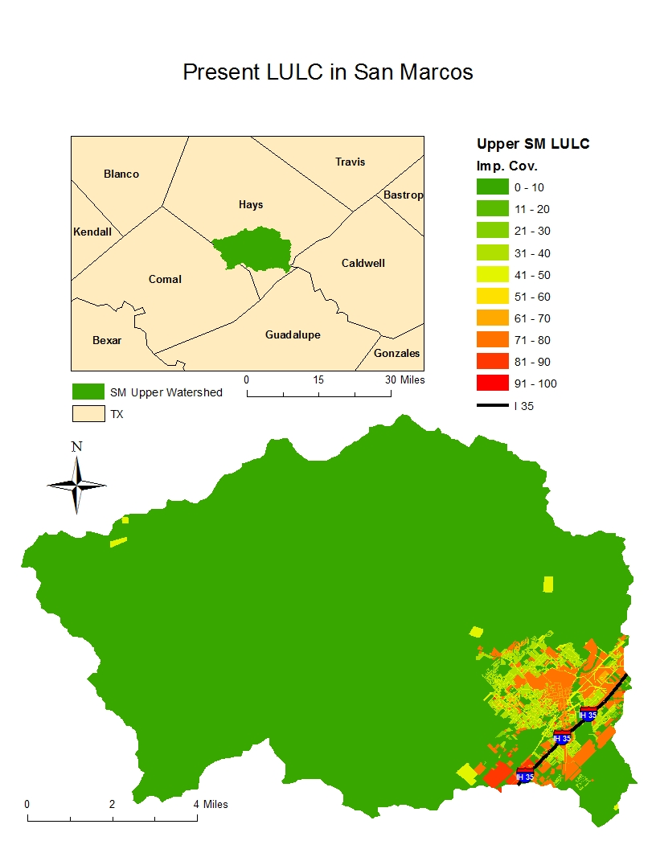
Figure 4. Preferred LULC
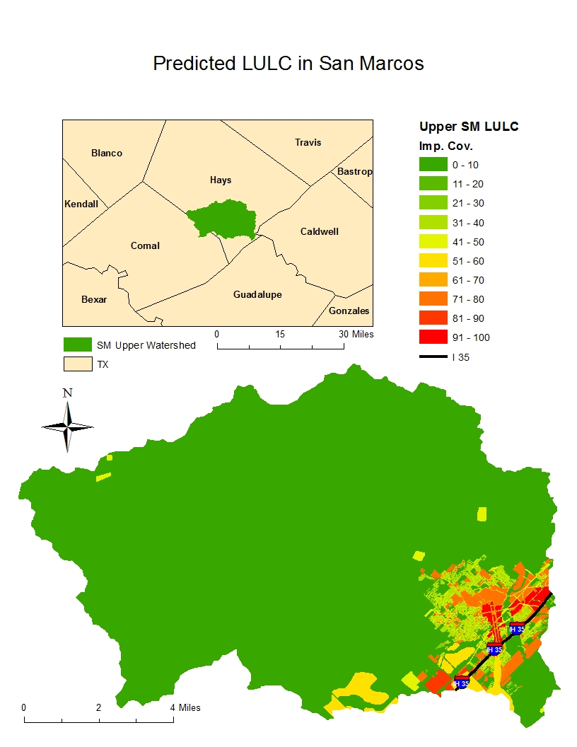
Figure 5. Watershed Delineation

Figure 6. Flowchart

Appendix II. Metadata
NHD Flowline
Identification_Information:
Citation:
Citation_Information:
Originator: Meadows Center for Water and the Environment
Title: NHD Flowline
Geospatial_Data_Presentation_Form: Vector Data
Series_Information:
Series_Name: National Hydrography Dataset Plus
Publication_Information:
Description:
Abstract: Polyline layer showing the San Marcos River system
Purpose: Hydrological modeling
Status:
Progress: Complete
Spatial_Domain:
Bounding_Coordinates:
West_Bounding_Coordinate: -98.710834
East_Bounding_Coordinate: -97.441820
North_Bounding_Coordinate: 30.162318
South_Bounding_Coordinate: 29.490619
Keywords:
Theme:
Theme_Keyword: San Marcos River network/system, hydrology
Place:
Place_Keyword: San Marcos River, San Marcos, Central Texas
Access_Constraints: None
Use_Constraints: This polyline layer represents the river network for the San Marcos River. It is used in hydrographic modeling.
Data_Quality_Information:
Attribute_Accuracy:
Attribute_Accuracy_Report: This data is accurate and free of errors.
Logical_Consistency_Report: Geometry type: Polyline, topology
Lineage:
Spatial_Reference_Information:
Horizontal_Coordinate_System_Definition:
Geographic:
Planar:
Map_Projection:
Transverse_Mercator:
Grid_Coordinate_System:
Universal_Transverse_Mercator:
UTM_Zone_Number: 14
Entity_and_Attribute_Information:
Overview_Description:
Entity_and_Attribute_Overview: Polylines represents streams forming the San Marcos River system.
Distribution_Information:
Distributor:
Contact_Information:
Contact_Organization_Primary:
Contact_Organization: Meadows Center for Water and the Environment
Contact_Address:
Address: 167 Spring Lake
City: San Marcos
State_or_Province: Texas
Postal_Code: 78666
Country: United States
Contact_Voice_Telephone: (512) 245-7570
Hours_of_Service: 9:30 amâ€“6:00
Metadata_Reference_Information:
Metadata_Date: December 7th, 2012
Metadata_Contact:
Contact_Information:
Contact_Person_Primary:
Contact_Person: Mark Hiler
Contact_Electronic_Mail_Address: markhiler@gmail.com
Metadata_Standard_Version: FGDC
Metadata_Access_Constraints: None
Metadata_Use_Constraints: None

Preferred LULC
Identification_Information:
Citation:
Citation_Information:
Originator: City of San Marcos
Publication_Date:
Publication_Time:
Title: Preferred Scenario Land Use San Marcos
Edition:
Geospatial_Data_Presentation_Form: Vector data
Series_Information:
Publication_Information:
Publication_Place: San Marcos, TX
Publisher: City of San Marcos
Online_Linkage:
Description:
Abstract: Layer showing the land use and various impervious cover percentages for the preferred build out scenario.
Purpose: This layer was created by the City of San Marcos to show the increase is urban areas and impervious cover with the increase in population.
Status:
Progress: Complete
Spatial_Domain:
Bounding_Coordinates:
West_Bounding_Coordinate: -98.715775
East_Bounding_Coordinate: -97.435547
North_Bounding_Coordinate: 30.167540
South_Bounding_Coordinate: 29.483232
Keywords:
Theme:
Theme_Keyword: impervious cover, land use
Place:
Place_Keyword: Land Use, San Marcos
Use_Constraints: This map represents the preferred build out scenario, it does not represent current land use. This product was created by the City of San Marcos during their Design Rodeo.
Point_of_Contact:
Contact_Information:
Contact_Organization_Primary:
Contact_Organization: City of San Marcos
Contact_Address:
Address: 630 East Hopkins Street
City: San Marcos
State_or_Province: Texas
Postal_Code: 78666
Country: United States
Contact_Voice_Telephone: (512) 393-8000
Data_Quality_Information:
Attribute_Accuracy:
Attribute_Accuracy_Report: This data is accurate and free of errors.
Completeness_Report: Complete
Positional_Accuracy:
Lineage:
Source_Information:
Source_Time_Period_of_Content:
Time_Period_Information:
Single_Date/Time:
Calendar_Date: Preferred land use for the for the year 2035
Source_Contribution: City of San Marcos created this map for use in the Comprehensive Master Plan
Spatial_Data_Organization_Information:
Spatial_Reference_Information:
Horizontal_Coordinate_System_Definition:
Planar:
Grid_Coordinate_System:
Grid_Coordinate_System_Name: NAD 1983 State Plane Texas South Central
Entity_and_Attribute_Information:
Overview_Description:
Entity_and_Attribute_Overview: Polygons represent varying levels of land use. Urban, Agriculture, and Underveloped. Various levels of impervious cover.
Distribution_Information:
Distributor:
Contact_Information:
Contact_Organization_Primary:
Contact_Organization: Meadows Center for Water and the Environment
Contact_Address:
Address: 167 Spring Lake
Contact_Voice_Telephone: (512) 245-7570
Hours_of_Service: 9:30 amâ€“6:00
Metadata_Reference_Information:
Metadata_Date: December 7th, 2012
Metadata_Contact:
Contact_Information:
Contact_Person_Primary:
Contact_Person: Mark Hiler
Contact_Electronic_Mail_Address: markhiler@gmail.com
Metadata_Standard_Version: FGDC
Metadata_Access_Constraints: None

Appendix III. Contributions of Each Team Member
Ekaterina Troudonochina
As the manager, it was my job to find out who was best at doing different tasks and delegate what needed to be done accordingly. I edited and formatted all of the papers and presentations. I spent some time with BASINS downloading the data and trying to make HSPF work. I succeeded briefly but nothing useful came out of my progress. I made some of the slides in the proposal presentation and most of the slides in the progress update presentation, and a few in the final presentation. I wrote a lot of the papers as well. For the final paper I did the headings, Abstract, Background, Purpose, Scope, Blind Salamander review, Data, Discussion, and Conclusion. I also made the Scope Map and both of the LULC maps. I also assisted in compiling the poster and the website.

Veronica Gentile
During the project I had a variety of tasks. Yet, on the finished paper I collaborated with the team manager, Kate, to help write and edit it. I researched prior power-point presentations for examples and with Kate gathered all the sections together to put in a cohesive presentation for the end result. I enjoyed editing and designing it with her. There was lots of work with BASINS and meetings with the Meadows Center. Unfortunately, I was only able to attend one of the meetings due to work schedule conflicts and lack of transportation capability. We initially attempted to do the BASINS training as a team. When complications kept reoccurring with BASINS as a group we decided to divide and conquer the situation. After the attempt at BASINs, I focused on literature reviews and then began to focus on the project results. I researched information based on the results of our project and then wrote the majority of the literature review sections, as well as the citations page. My past writings helped contribute to the Background, Problem statement, Analysis, and Conclusion. Lastly, I was the main creator and organizer of the professional poster. Throughout these past months I believe I was helpful to our team, and manager, with editing, communication, and organization.

Mark Hiler
Throughout the project, team members evenly distributed the work load, sometimes working on the same tasks, sometimes on different ones. In the beginning, one of my jobs was data collection. From the very start, I have been involved with the data since in the writing of documents and presentation sections pertaining to data. Research on our endangered species was a task in which all participated in. I helped to find living thresholds for the Texas Wild Rice and Fountain Darter as well as finding the TCEQ Water Quality Standards for the San Marcos River. For the second half of the project I primarily focused my attention on trying to work with the program BASINS and the model HSPF, visiting with Meadows Center staff for assistance. In writing the final proposal, I wrote about methodology, results, software used, and metadata.

Julian Montejano
I worked as the team’s web master. I helped create a professional, clean website containing all of our work as a team on the project. I was the point of contact for the team and helped arrange several meeting with our clients, Dr. Thom Hardy and Melani Howard. I also helped keep in contact with the Meadows Center GIS team for help with the San Marcos watershed project. In addition to that, I did some work with Mark Hiler to help with GIS analysis.

